Biobased Hybrid Latexes – A Case Study with Agricultural Based Waterborne Polyurethanes

Thomas F. Garrison, Mahendra Thunga, Daniel P. Pfister, Michael R. Kessler,* Richard C. Larock*

–––––––––

Dr. Thomas F. Garrison, Dr. Daniel P. Pfister, Prof. Richard C. Larock

Department of Chemistry, Iowa State University, 50011 Ames, IA, USA

E-mail: larock@iastate.edu

Dr. Mahendra Thunga, Prof. Michael R. Kessler  
Department of Materials Science and Engineering, Iowa State University, 50011 Ames, IA, USA

Email: mkessler@iastate.edu

Prof. Michael R. Kessler

Department of Mechanical Engineering, Iowa State University, 50011 Ames, IA, USA

Prof. Michael R. Kessler

Ames Laboratory, US Department of Energy, 50011 Ames, IA, USA

–––––––––

The growing concerns on environment pollution and decreasing fossil fuel reserves has driven recent interest in developing environment friendly, biorenewable materials for designing advanced coating materials. The focus of this feature article is to review developments in biobased hybrid latex coatings and present a case study of our recent work. In the case study, we examine the use of 2-hydroxyethyl acrylate in improving the grafting density of vinyl group on castor oil-based waterborne polyurethane dispersions (PUDs). Grafted hybrid latexes have been prepared from the waterborne polyurethane dispersions with different concentrations of 2-hydroxyethyl acrylate by emulsion graft copolymerization of vinyl monomers. The thermo-physical properties have been investigated using dynamic mechanical analysis and differential scanning calorimetry. Increased ratios of 2-hydroxyethyl acrylate in the grafted hybrid latexes, increase the elongation at break and glass transition temperature. The elastic properties of the materials were characterized by tensile testing and the tensile stress/strain curves modeled by Mooney-Rivlin equation for rubber elasticity revealed the influence of 2-hydroxyethyl acrylate on the cross-link density.

**Introduction**

Conventional organic solvent-borne polyurethanes have been widely adopted commercially because of their appearance and high performance characteristics, such as high tensile strength, abrasion resistance, chemical resistance, and toughness.[1, 2] Organic solvents have traditionally been used because they are effective at dissolving binders and homogenizing coating blends, controlling viscosity, increasing shelf life, and wetting the substrate surface.[3, 4]

However, organic solvents pose significant risks due to environmental, industrial, and fire safety concerns.[4] The environmental impact of organic solvent-borne polyurethanes due to emissions of volatile organic compounds (VOCs) both during processing and during the application lifetime is a critical concern.[1] Processing and manufacturing of coatings account for the second leading source of human caused atmospheric pollutants, behind vehicular traffic.[3] With greater public and regulatory emphasis on using environmentally-friendly processes, alternatives to solvent-borne coatings, such as waterborne coatings like polyurethane dispersions, offer increasing advantages to both consumers and manufacturers.[1] While other coating strategies have also been designed to reduce VOCs, including high solids coatings, powder coatings, and radiation curable coatings, these other coating systems are outside the scope of this discussion.[5]

Hybrid polymeric materials have been synthesized as strategy of overcoming the aforementioned deficiencies of polyurethane dispersions and other polymers. Often, hybrid polymers refer to polymers covalently bonded to inorganic materials or polymers with encapsulated nanoparticles.[6-8] Hybrid polymer systems can also include two or more different types of polymers that are normally incompatible, such as thermosets and thermoplastics.[6] In the present context, the term hybrid polymers refer to the combination of thermoset polyurethanes and thermoplastic acrylic latexes.[9] Acrylic resins have a number of advantages, including good weatherability, chemical resistance, gloss, and affinity to pigments.[10] However, acrylic resins often exhibit poor toughness, elongation, mar resistance, and adhesion.[10] Hybrid polyurethane latexes offer the potential of combining the advantages of both acrylic latexes and waterborne polyurethane dispersion systems, while offering lower cost and good affinity to pigments.[10, 11]

Another drawback of conventional coatings is their dependence on a petroleum-based polymers and solvents. In recent years, considerable research has focused on the replacement of petroleum-based starting materials for polyurethanes with biorenewable-based materials.[12-14] In response to the dual concerns about dwindling petroleum reserves and VOC emissions, waterborne polyurethane dispersions have been prepared using biorenewable-based polyols, such as vegetable oils or fatty acids.[15-19]

**Polyurethane Dispersions**

Polyurethane dispersions (PUDs) are widely used polymers with a diverse range of applications, including paints, inks, coatings, adhesives, paper and textiles.[20, 21] They are excellent choice of materials for reducing the emission of volatile organic compounds (VOC) generated by organic solvents.[1, 20, 21] In comparison with other waterborne coatings, waterborne PUDs have the lowest amounts of organic solvent emissions with amounts as low as 3 wt. %.[3] PUDs offer various advantages, including excellent processability and good film forming properties. The fundamental property of PUDs that is responsible for easing their processability is the shear viscosity. Unlike conventional polymer solutions, the shear viscosity of PU dispersion is independent of molecular weight (*Mw*) of the polymer which enables designing PU dispersion with high solid content and *Mw.*[20, 22] In fact, high solid concentrations and high *Mw* are known to have significant influence on the performance and durability of PUDs after drying.[9] However, PUDs have various disadvantages, which include high cost, slow drying rates, and poor water and alkali resistance.[22, 23]

Waterborne polyurethane dispersions have been developed to overcome the processing and functional problems in conventional PUDs. Waterborne PUDs have attracted extensive scientific interest as a special class of materials both in terms of fundamental and practical applications. The performance and durability of waterborne PUDs was evaluated to be comparable to those of emulsion coatings. Some of the common applications of waterborne polyurethane dispersions include floor coatings,[24] textile coatings,[25, 26] and adhesives.[27] Acetone process, prepolymer mixing process, melt dispersion process, and ketimine/ketazine process are commonly used methods for synthesizing waterborne PUDs [29] and acetone process is most widely used in industry.[29] In acetone process, polyurethane chains are extended initially with hydrophilic groups incorporated into the polymer backbone.[30] Acetone is primarily used to reducing the viscosity of the solution during the synthesis. In a later step, water is added to the mixture to form the dispersion. In the final step, the diluent acetone will be removed using distillation.[31] In this process, acetone is often replaced by other solvents, such as methyl ethyl ketone to suite the application [15, 25]

**Emulsion Coatings**

Emulsion polymerization produces latex particles, which are dispersions of fine polymer particles in water.[5, 32, 33] Frequently, the terms emulsion coating and latex paint are used interchangeably. Applications of emulsion coatings include paints, coatings, adhesives, and paper coatings.[33]

Emulsion coatings have a number of desirable physical properties. Styrene-butadiene latex paints for interior walls were first sold commercially in the United States in the late 1940s.[34, 35] These paints appealed to consumers because of their easy application, low odor, and easy clean-up.[34, 35] Acrylic latexes are known for high molecular weights with good corrosion resistance and are generally more economical than polyurethane coatings.[4, 32, 36] However, acrylic latexes have poor film forming properties, abrasion resistance and toughness compared to polyurethane dispersions.[24, 37]

A typical formulation for emulsion polymerization consists of a slightly water-soluble monomer, co-monomers, a water-soluble initiator, surfactants, and any other additives, which are combined in an aqueous solution.[4] In emulsion polymerization, monomers are polymerized through a free-radical process. The monomer molecules migrate from the monomer droplets to inside surfactant micelles, where the polymerization actually occurs.[3, 4, 32] Polymerization begins when a water-soluble initiator molecule enters a micelle and reacts with the monomer. These micelles form when the surfactant concentration is above a minimum concentration, called the critical micelle concentration.[32] As polymerization progresses, the monomer droplet size decreases and the size of the polymer-containing micelles increase.[4, 32] The resulting aqueous suspension of polymers is called a latex.[32]

**Hybrid Materials**

A number of different approaches exist for making hybrid materials. Physical blending is the simplest route and most common method used industrially,[9, 37, 38] However, the improved performance is obtained when the blended polymers are covalently bonded together. This has been achieved by cross-linking, mini-emulsion, and seeded emulsion.[37-39] Hybrid latexes prepared from mini-emulsion and seeded emulsion polymerization have been reviewed extensively.[6, 40] In mini-emulsion, polycondensate or polyaddition polymers, such as polyesters, alkyd resins, or polyurethanes, are dissolved in radically polymerizable monomer(s).[6] In seeded emulsion polymerization, a modified polycondensate polymer first forms a latex in the presence of water, and this latex is used as a seed in an emulsion polymerization of suitable monomers.[6, 10, 11, 41]

Waterborne polyurethane hybrid latexes is an area of particular interest in waterborne coatings research.[17-19, 23, 42-44] Previously, our group has reported the synthesis of vegetable oil-based urethane-acrylic latexes[17, 45, 46] More recently, our group reported curing castor oil-based waterborne polyurethane dispersions with an aziridine-based crosslinker.[47]

**Case Study**

In the present work, 2-hydroxyethyl acrylate (HEA) has been incorporated into castor oil-based PUDs as a precursor to making grafted hybrid latex dispersions from waterborne castor oil-based polyurethane dispersions.[48] It is well known that HEA is commonly used as a cross-linking agent by introducing hydroxyl (-OH) groups.[9] However, the objective of this work is to investigate the role of HEA in introducing vinyl groups for grafting in the preparation of castor oil-based grafted hybrid latexes (GHL). The advantage of using castor oil and HEA over acrylated soybean oil is that it eliminates the need for additional processing of soybean oil by epoxidation and ring opening with acylated groups. The effect of different molar ratios of vinyl monomers (styrene and butyl acrylate) on the resulting GHL was also examined. Recently, styrene and butyl acrylate were used to prepare hybrid polyurethane latexes from polyester-based polyurethanes, which showed excellent properties as a paper surface sizing agent in papermaking.[49] The morphology and properties of these GHLs have subsequently been investigated using transmission electron microscopy, mechanical testing, dynamic mechanical analysis, differential scanning calorimetry, and thermogravimetry. Mooney-Rivlin model for rubber elasticity was used to determine molecular weight between cross-links.

**Results and Discussion**

**TEM Microscopy**

The transmission electron microscopy images of the polyurethane particles and grafted hybrid latex particles, shown in **Figure 1**, illustrate the change in particle morphology based on HEA ratio. For the PUDs, the particles were spherical or oblong and relatively hard to observe in comparison to the grafted hybrid latex particles (Figure 1a). In contrast, the grafted hybrid latexes with HEA molar ratios 0.2 or less (Figure 1b), showed well defined spherical particles typically larger than 200 nm in size. However, the GHL-0.3 particles (Figure 1c) were much smaller (less than 100 nm), with irregular shapes, and were more disperse than those observed for GHL-0.2. The transition in observed morphology from GHL-0.2 to GHL-0.3 indicates a change in polymer structure, which can possibly be attributed to a decreased molecular weight of the polyurethane backbone due to an excess of HEA. When HEA is incorporated into a step growth polymer, it also acts as a chain terminator, in addition to being a graft site for acrylic polymer chains. The observed morphology changes are consistent with the results of the thermomechanical testing.

The morphology of the GHL-0.2 particles also exhibits a hybrid structure, instead of a core-shell structure. In a core-shell structure, there are clearly defined layers with a hydrophobic core and a hydrophilic shell.[46] However, in the GHL-0.2 particles, the broad distribution of osmium tetroxide stain indicates that the grafted latex particles have a hybrid structure, instead of a core-shell structure. The osmium tetroxide preferentially reacts with the carbon-carbon double bonds that are only found in the castor oil-based polyurethane chains. This indicates that the particle interior is a hybrid mixture of grafted polyvinyl chains and polyurethane chains, whereas the particle surface is covered with the hydrophilic anionomer groups incorporated into the polyurethane chains.

**Mechanical Properties**

Tensile tests were conducted to determine the stress-strain behavior of vinyl-containing polyurethanes (PU) and the grafted hybrid latex (GHL) films. The stress strain curves PU and GHL films with different concentrations of HEA are presented in Figure 2a and 2b respectively and the test results are summarized in **Table 2**. For the PU films, the tensile strength decreased, while the elongation at break increased as the molar ratio of HEA increased from 0.0 to 0.2. PU-0.3 had a higher Young’s modulus and toughness compared to the other PU films, as well as greater variability in the toughness and elongation at break. For the grafted hybrid latex films, the tensile strength decreased from 2.56 MPa to 1.21 MPa as the HEA concentration increased from 0.0 to 0.3, but it improved relative to the corresponding vinyl-containing polyurethane. The Young’s modulus of the grafted latexes increased from 1.79 to 4.39 MPa as the HEA molar ratio increased from 0.0 to 0.3. The elongation at break remained relatively constant as the HEA increased, but decreased slightly as the HEA molar ratio increased from 0.2 to 0.3. It should be noted that for both PU and GHL films a decrease in stress and strain at break observed as the HEA molar increased from 0.2 to 0.3 is consistent with the changes in particle morphology.

The Mooney-Rivlin equation, as shown in **Equation 1**, can be used to estimate the molecular weight between crosslinks (*Mc*) from the stress-strain behavior as shown in **Equation 2**, where *σ* is the tensile stress, λ is the stretch ratio, C1 and C2 are experimentally determined parameters, *ρ* is the density of the polymer, *R* is the gas constant, and *T* is the absolute temperature.[50, 51]

The tensile data conforms to Equation 1, as shown in Figure 3. The values for *M*c are listed in **Table 3**. The crosslink density is inversely proportional to *M*c. For the vinyl-containing polyurethane films, *M*c increased with increasing amounts of HEA, whereas for the grafted hybrid latex films, *M*c did not change as the HEA molar ratio increased from 0.2 to 0.3. The model was not applied to the samples PU-0.3 and GHL-0.3 with the highest amounts of HEA, because of changes in the morphology and behavior. Figure 3 illustrates that there was an absence of a rubbery plateau for PU-0.3.

**Thermal Properties**

The storage modulus (*E*’) of both the vinyl-containing PUs and the grafted hybrid latex films are shown in **Figure 4**aand **4b**, respectively. The storage modulus of the vinyl-containing PUs decreased as the ratio of HEA increased. The decrease in the modulus is more evident because of HEA causing more chain termination, leading to more dangling chains. These dangling chains may platinize the segmental relaxation in the polymer chains resulting in reducing the modulus of the material. The decrease in storage modulus can also be attributed to the cross-link density of the PU matrix. In contrast, the storage modulus increased for the GHL samples as the ratio of HEA increased, which can be explained by the fact that the concentration of castor oil responsible for controlling the flexibility of the GHL films is decreasing.

The glass transition temperatures, *T*g’s, of both the vinyl-containing polyurethanes and the grafted hybrid latexes have been determined using DMA and DSC, as summarized in **Table 4**. With DMA, the apparent peak in the tan δ curves corresponds to the glassy transition (*T*g) whereas DSC determines the same by measuring changes in the heat capacity between the glassy and rubbery states. Both methods exhibit similar trends. However, the *T*g determined by DSC is lower than the *T*g determined by the tan δ peak in the DMA. The *T*g of the vinyl-containing polyurethanes decreased as the ratio of the HEA increased from 0.0 to 0.2 and then increased only slightly as the ratio of the HEA increased from 0.2 to 0.3. In contrast, the *T*g of the grafted hybrid latexes increased as the ratio of the HEA increased, which indicates improved grafting of the vinyl monomers. In addition, the presence of single glass transitions is an indication of homogeneous GHL when compared with polymer blend.[45]

The thermal stability of the films has been investigated using thermogravimetric analysis (TGA). The two TGA parameters reported in Table 4 are the temperatures of 5% and 50% degradation (*T*5 and *T*50, respectively). The parameter *T*5 corresponds to the onset degradation temperature, while the parameter *T*50 corresponds to the mid-point temperature of degradation. Both the vinyl-containing PU and the GHL samples exhibit a decreasing trend for *T*5 with the increase in the concentration of HEA. However, in case of *T*50, the vinyl-containing PU samples showed a decreasing, while for the grafted hybrid latexes, *T*50 increased with the HEA ratio. The increase in *T*50 for the grafted hybrid latexes indicates that grafting improves the thermal stability.

**Vinyl monomer composition**

Styrene and butyl acrylate are two common monomers used in the synthesis of commercial latex emulsions. Styrene is typically used to reduce cost and impart hardness to the dried film, whereas butyl acrylate is used to add flexibility. For the grafted hybrid latexes, the thermal properties of two additional monomer compositions have been examined, namely butyl acrylate: styrene ratios of 3: 1 and 1: 3, in addition to the 1: 1 data presented above. As expected, the butyl acrylate-rich grafted hybrid latex exhibits a lower storage modulus owing to more flexible segments, while the styrene-rich grafted hybrid latex is more rigid, as shown in **Figure 6**. The vinyl monomer composition did not significantly influence the *T*g (data not shown).

**Conclusions and Future Outlook for Biobased Hybrid Latexes**

Vinyl-containing waterborne PUDs have been successfully synthesized from castor oil, where HEA has been used to introduce vinyl groups for subsequent grafting. The grafted hybrid latexes prepared exhibit improved thermal and mechanical properties over the vinyl-containing polyurethanes. However, excessive amounts of HEA relative to castor oil significantly change both the morphology and the properties of the grafted hybrid latexes. Generally, it was observed that as the molar ratio of HEA increases from 0.2 to 0.3 and as the molar ratio of castor oil simultaneously decreases, there is a significant change in the particle size, morphology, thermal properties, and mechanical properties. Two competing phenomenon are likely to contribute to the results. Castor oil acts as both a cross-linker and a soft chain supplier, whereas HEA acts as both a chain terminator and as a graft site for polyvinyl chains. Consequently, changes in the relative composition of HEA and castor oil significantly impact the properties of the films.

For the grafted hybrid latexes, increases in the ratio of the HEA improve the properties of the materials. It is also observed that changing the vinyl monomer composition changes the properties of the materials. From these observations, we conclude that both the HEA and vinyl monomer ratios can be tuned to improve the properties of grafted hybrid latexes.

**Hysterisi Responce**

Tensile hysterisis tests were conducted on the PU and GHL film samples to evalute the strain dependent damping properties of the materials. Cyclic stress-strain measurements were used to measeure the energy-loss during dynamic deformation in these soft elastomeric samples. Spcifically, hysterisis results can be used to stude the micro mechanical behaviour [[1]] by correlating the local morphology of the material with the bulk mechanical properties.

The stress-strain curves of cyclic loading and unloading for the PU samples are shown in Figure 7a to 7c, while the curves for the GHL samples are shown in Figure 8a to 8c. Representative stress-strain curves from normal tensile tests on the same sampes are also plotted as dotted line curves in the figures. As the area of the hysterisis loop can be directly related to the energy-loss in each cycle, the change in hysterisis work with increase in strain can be calculated in percentage by using equation X.

$H_{\% }=\left[\frac{H_{loading }-H_{unloading }}{H_{loading }}\right]×100\%$

where, *Hloading* and *Hunloading* are measured as area under the loaded and unloaded curves respectively. The histerisis-work calculated for PU ansd GHL samples are shown in Figure 7d and 8d respectively.

In soft croslinked materials, the disruption of the network structure at low strain is associated with, breaking the overall microstructure of the material followed by positioning the structure in the direction parallel to the deformation axes. This disruption result in high energy loss with a maximum hysteresis-work at low strain as observed in Figure 7d and 8d. The hysteresis work in this strain regime is primarily controlled by the crosslinking density of the polymer matrix. As the network density of the investigated samples is increasing with the HEA content, a high hysteresis-work can be observed for PU and GHL sample with high HEA content. However, at high strains regimes, the networker deformation is primarily controlled by rearrangement of the structure and relaxation of the entangled polymer chain between the crosslinks. Less mechanical energy is expected to dissipate during the cyclic deformation in this strain regime. Accordingly, with increase in strain above yielding point, the H% of all the samples appears to reduce. Although, the H% curves of the samples show a similar H% decreasing trend with increase in strain, the distinct difference in the crosslinking density between the samples reveals difference in the relative H% values.

The overall stress at break decreases as HEA content increases for both the PU and GHL samples. This same trend was observed in the cyclic loading and unloading curves. The GHL had higher stresses as well as a larger area underneath the curves, indicating the acrylic grafting increased the toughness of the materials. However, the GHL samples decreased in stress at break and strain at break as the amount of HEA increased. This is consistent with other observed results that indicate excessive amounts of HEA reduced the overall molecular weight of the GHL samples due to chain termination during the polyurethane synthesis step.

Acknowledgements:

We gratefully acknowledge financial support from the Consortium for Plant Biotechnology Research (CPBR) and the Archer Daniels Midland (ADM) Company. We also thank Ms. Tracey M. Pepper of the Microscopy and NanoImaging Facility (MNIF) at Iowa State University for her assistance with the TEM analysis.

Keywords: hybrid latexes; castor oil; 2-hydroxyethyl acrylate; polyurethanes

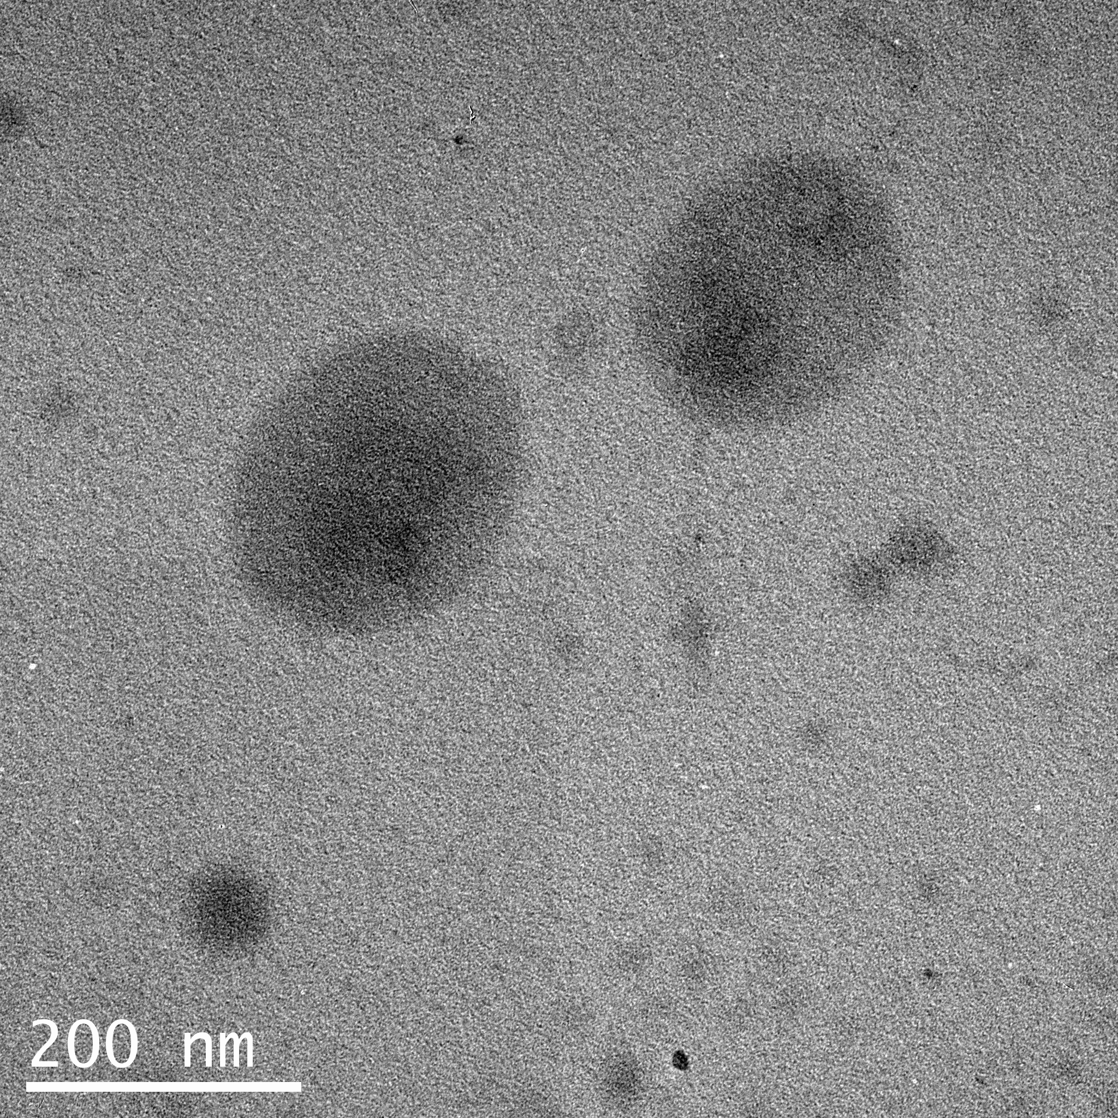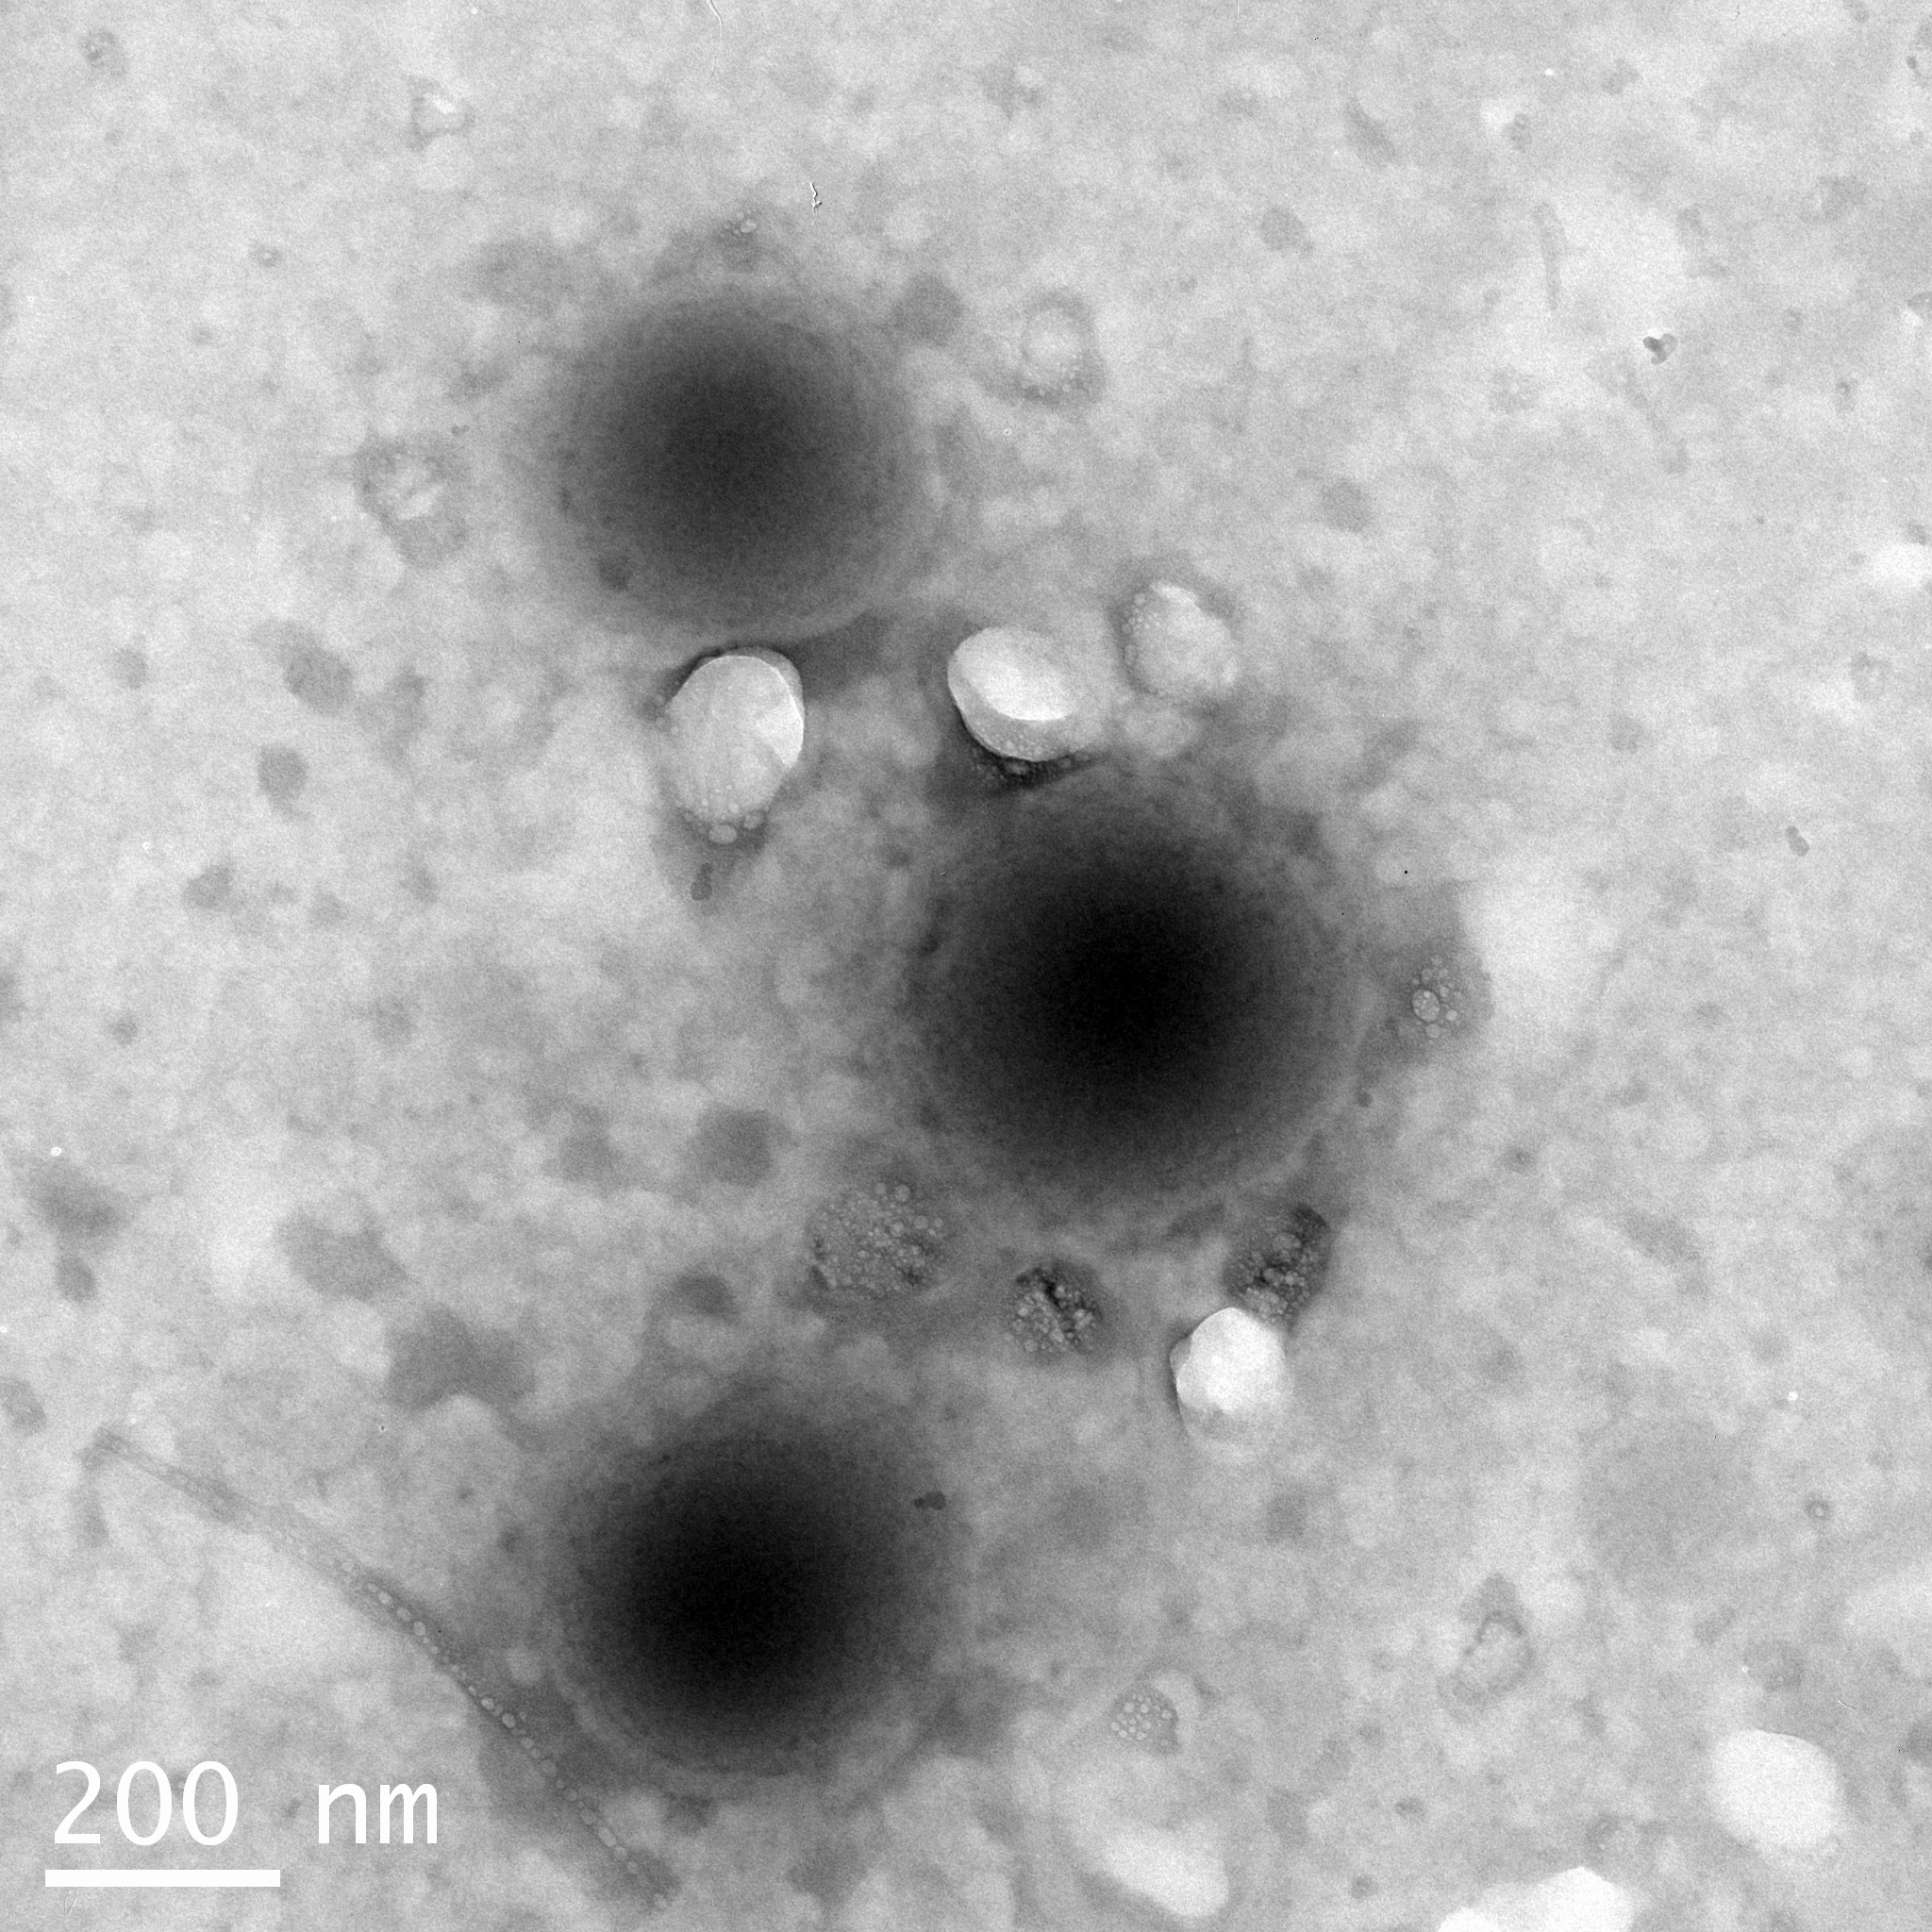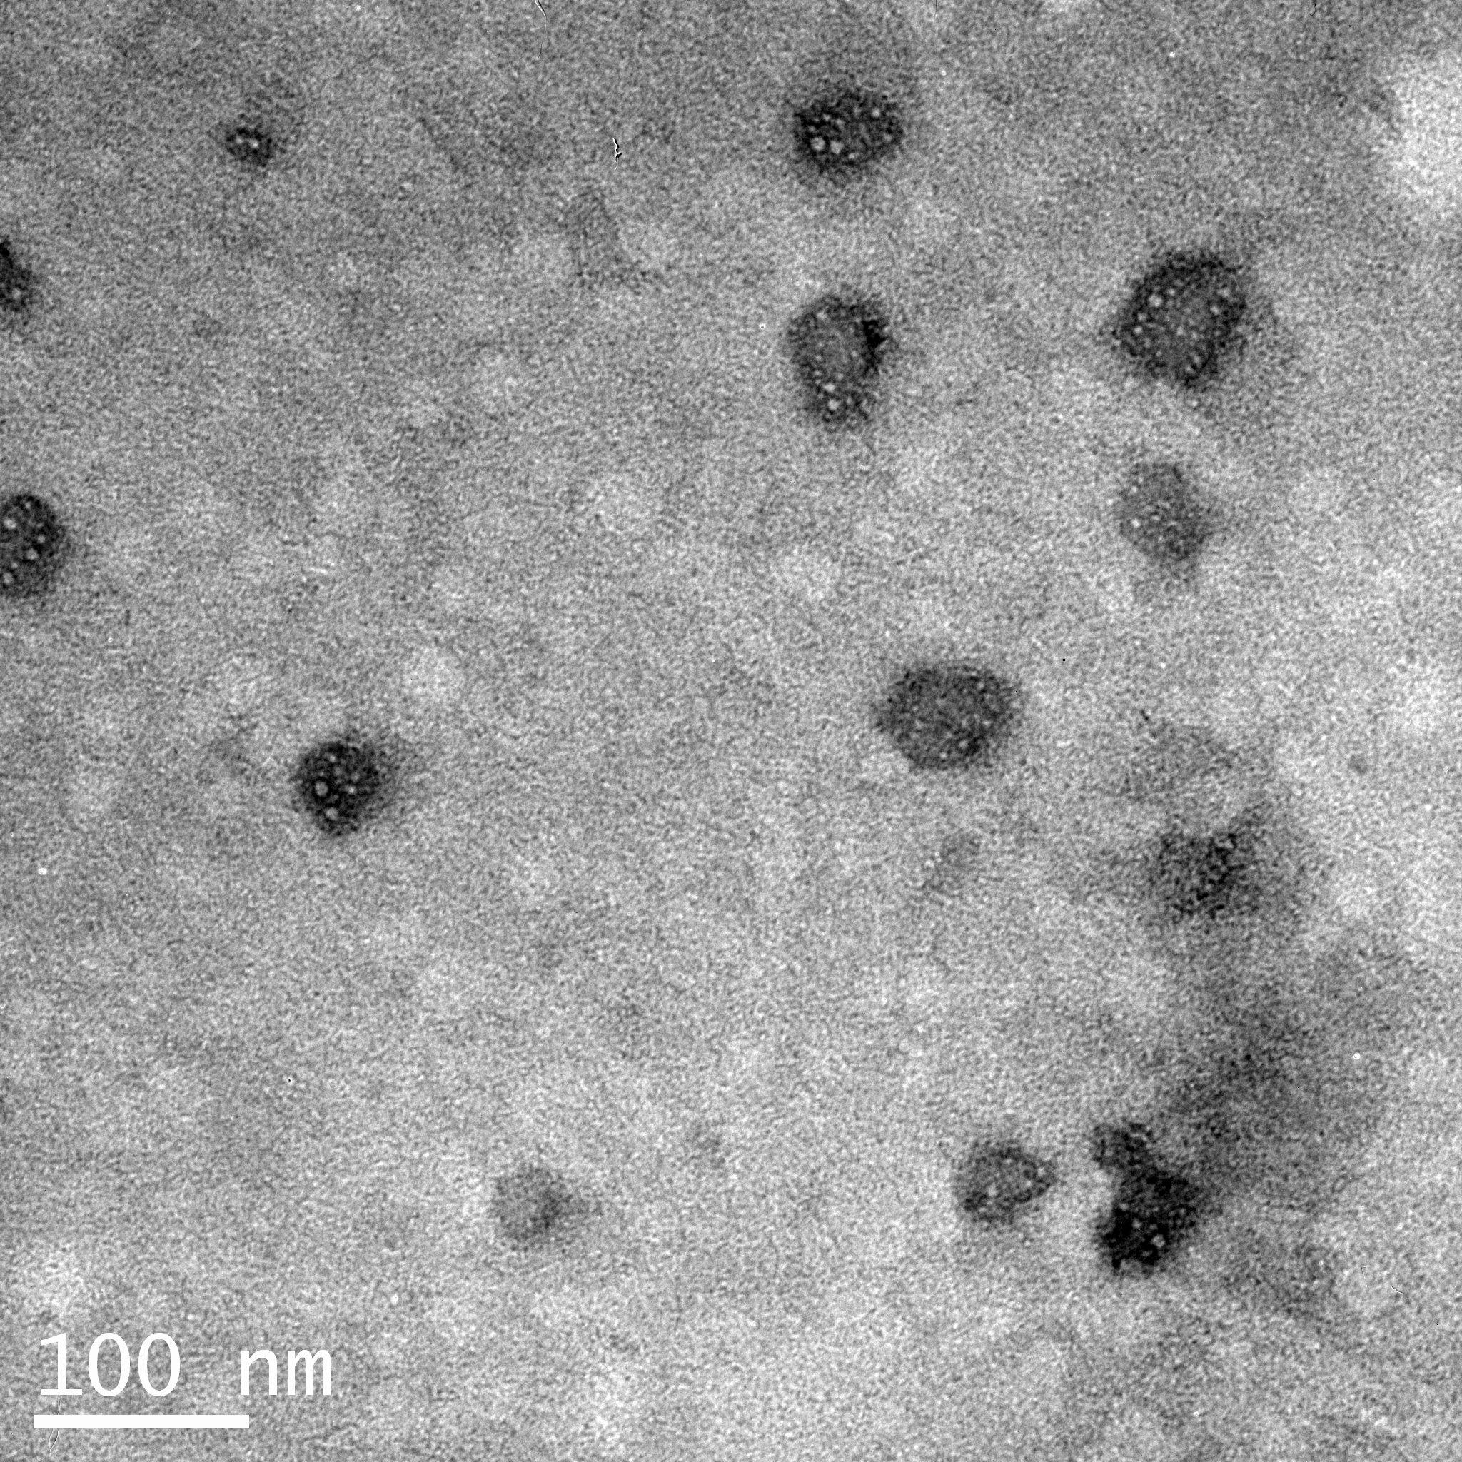

c

a

b

Figure : TEM microphotographs of particles from the PU-0.0 dispersion (a) and grafted latexes of GHL-0.2 (b) and GHL-0.3 (c).

Table : Chemical composition of PU and GHL films

|  |  |  |  |  |  |
| --- | --- | --- | --- | --- | --- |
|  | Molar Ratio | | | | Vinyl Monomers |
| Sample | NCO (IPDI) | OHa) | OHb) | OHc) | (wt%) |
| PU-0.0 | 2.0 | 1.0 | 0.99 | 0.0 | 0 |
| PU-0.1 | 2.0 | 0.9 | 0.99 | 0.1 | 0 |
| PU-0.2 | 2.0 | 0.8 | 0.99 | 0.2 | 0 |
| PU-0.3 | 2.0 | 0.7 | 0.99 | 0.3 | 0 |
| GHL-0.0 | 2.0 | 1.0 | 0.99 | 0.0 | 30 |
| GHL-0.1 | 2.0 | 0.9 | 0.99 | 0.1 | 30 |
| GHL-0.2 | 2.0 | 0.8 | 0.99 | 0.2 | 30 |
| GHL-0.3 | 2.0 | 0.7 | 0.99 | 0.3 | 30 |

a) Hydroxyl molar ratio of the castor oil, b) Hydroxyl molar ratio of the DMPA, c) Hydroxyl molar ratio of the HEA

*Table 2:* Summary of engineering stress data

|  |  |  |  |  |  |
| --- | --- | --- | --- | --- | --- |
|  | HEA  Molar Ratio | σb  (MPa)a) | E  (MPa)b) | Toughness (MPa) | εb  (%)c) |
| PU | 0.0 | 1.57 ± 0.10 | 1.01 ± 0.19 | 2.31 ± 0.17 | 319 ± 12 |
| 0.1 | 1.49 ± 0.21 | 0.97 ± 0.11 | 2.97 ± 0.47 | 435 ± 34 |
| 0.2 | 0.88 ± 0.06 | 1.01 ± 0.13 | 2.16 ± 0.10 | 560 ± 19 |
| 0.3 | 1.16 ± 0.11 | 1.75 ± 0.11 | 3.85 ± 0.68 | 539 ± 69 |
|  |  |  |  |  |  |
| GHL | 0.0 | 2.56 ± 0.17 | 1.79 ± 0.10 | 4.61 ± 0.39 | 396 ± 18 |
| 0.1 | 2.10 ± 0.17 | 2.50 ± 0.20 | 3.98 ± 0.34 | 396 ± 14 |
| 0.2 | 1.61 ± 0.06 | 2.50 ± 0.32 | 3.08 ± 0.13 | 401 ± 10 |
| 0.3 | 1.21 ± 0.10 | 4.39 ± 0.27 | 3.08 ± 0.24 | 364 ± 13 |

a) σb is break strength, b) E is Young’s modulus, c) εb is the strain at break

Equation :



Equation :



Table : Molecular weight between crosslinks (Mc) estimated from Mooney-Rivlin plots

|  |  |  |  |
| --- | --- | --- | --- |
|  | *M*c  (kg / mol) |  | *M*c  (kg / mol) |
|  |  |  |  |
| PU 0.0 | 5.9 | GHL 0.0 | 4.8 |
| PU 0.1 | 9.3 | GHL 0.1 | 8.2 |
| PU 0.2 | 16.1 | GHL 0.2 | 8.1 |
| PU 0.3 | n/a | GHL 0.3 | n/a |



Figure : Tensile stress strain curves a) for PU and b) GHL films



Figure : Mooney-Rivlin plot for PU films with different molar ratios of HEA.



Figure :Storage modulus as a function of temperature for polyurethane films with different amounts of HEA



Figure : Storage modulus as a function of temperature for grafted hybrid latex films with different amounts of HEA

Table : Summary of Thermal Properties

|  |  |  |  |  |  |
| --- | --- | --- | --- | --- | --- |
|  |  |  |  | TGA | |
|  |  | *T*g (DMA) | *T*g (DSC) | *T*5 | *T*50 |
|  | HEA Molar Ratio | (°C) | (°C) | (°C) | (°C) |
|  |  |  |  |  |  |
| PU | 0.00 | 6.28 | -18.60 | 232 | 373 |
| 0.10 | 4.88 | -20.80 | 218 | 361 |
| 0.20 | 3.80 | -21.70 | 220 | 359 |
| 0.30 | 11.46 | -19.60 | 219 | 357 |
|  |  |  |  |  |  |
| GHL | 0.00 | 9.36 | -19.80 | 231 | 391 |
| 0.10 | 14.92 | -16.10 | 228 | 392 |
| 0.20 | 15.98 | -9.30 | 228 | 403 |
| 0.30 | 20.31 | -4.80 | 224 | 413 |



*Figure 6:* Storage modulus as a function of temperature for GHL-0.3 films with different vinyl monomer compositions



Figure 7. Hysteresis response of cyclic tensilebehavior of polyurethane films with different concentrations of HEA.



Figure 8. Hysteresis response of cyclic tensile behavior of grafted hybrid latex films with different concentrations of HEA.

.

[1] K.-L. Noble, *Prog. Org. Coat.* **1997**, *32*, 131.

[2] A. Overbeek, *J. Coat. Technol. Res.* **2010**, *7*, 1.

[3] K. Dören, W. Freitag, D. Stoye, "*Water-Borne Coatings: The Environmentally-friendly Alternative"*, Hanser Publishers, Munich, 1994.

[4] A. Marrion, "The Chemistry and Physics of Coatings", Royal Society of Chemistry, Cambridge, UK, 1994.

[5] K. D. Weiss, *Prog. Polym. Sci.* **1997**, *22*, 203.

[6] A. Guyut, K. Landfester, F. J. Schork, C. Wangd, *Prog. Polym. Sci.* **2007**, *32*, 1439.

[7] C. K. Weiss, K. Landfester, "Miniemulsion Polymerization as a Means to Encapsulate Organic and Inorganic Materials", in *Hybrid Latex Particles*, A.M. VanHerk and K. Landfester, Eds., 2010, p. 185.

[8] A. P. Zhu, Q. P. Rong, R. Chen, *J. Adhes. Sci. Technol.* **2010**, *24*, 267.

[9] Z. W. Wicks, Jr., F. N. Jones, S. P. Pappas, D. A. Wicks, "*Organic Coatings: Science and Technology"*, Third edition, John Wiley & Sons, Inc., Hoboken, NJ, 2007.

[10] M. Hirose, F. Kadowaki, J. Zhou, *Prog. Org. Coat.* **1997**, *31*, 157.

[11] M. Hirose, J. Zhou, K. Nagai, *Prog. Org. Coat.* **2000**, *38*, 27.

[12] M. A. R. Meier, J. O. Metzger, U. S. Schubert, *Chem. Soc. Rev.* **2007**, *36*, 1788.

[13] Z. S. Petrovic, *Polym. Rev.* **2008**, *48*, 109.

[14] Y. Xia, R. C. Larock, *Green Chem.* **2010**, *12*, 1893

[15] Y. Lu, R. C. Larock, *Biomacromolecules* **2008**, *9*, 3332.

[16] A. Patel, C. Patel, M. G. Patel, M. Patel, A. Dighe, *Prog. Org. Coat.* **2010**, *67*, 255.

[17] Y. Lu, R. C. Larock, *Biomacromolecules* **2007**, *8*, 3108

[18] Y. Xia, R. C. Larock, *Green Chem.* **2010**, *12*, 1893.

[19] United States. US 6,166,150 (2000), BASF Coatings AG, invs.: G. Wilke, U. Poth, R. Seidemann, V. Kadambande; *USPTO*

[20] B. K. Kim, *Colloid Polym. Sci.* **1996**, *274*, 599.

[21] S. Y. Lee, J. S. Lee, B. K. Kim, *Polym. Int.* **1997**, *42*, 67

[22] Y. Lu, R. C. Larock, "Novel Biobased Plastics, Rubbers, Composites, Coatings and Adhesives from Agricultural Oils and By-Products", in *Green Polymer Chemistry: Biocatalysis and Biomaterials*, American Chemical Society, 2010, p. 87.

[23] H. Fu, H. Huang, Q. Wang, H. Zhang, H. C. HQ, *J. Disper. Sci. Technol.* **2009**, *30*, 634.

[24] G. A. Howarth, *Surf. Coat. Int. Pt. B-Coat. Trans.* **2003**, *86*, 111.

[25] H. Pan, D. Chen, *Text. Res. J.* **2009**, *79*, 687.

[26] Q. B. Meng, S.-I. Lee, C. Nah, Y.-S. Lee, *Prog. Org. Coat.* **2009**, *66*, 382

[27] E. Orgilés-Calpena, F. Arán-Aís, A. M. Torró-Palau, C. Orgilés-Barceló, J. M. Martín-Martínez, *Int. J. Adhes. Adhes.* **2009**, *29*, 774.

[28] O. Jaudouin, J. J. Robin, J. M. Lopez-Cuesta, D. Perrin, C. Imbert, *Polym. Int.* **2012**, *61*, 495.

[29] V. D. Athawale, R. V. Nimbalkar, *J. Am. Oil Chem. Soc.* **2011**, *88*, 159.

[30] G. N. Manvi, R. N. Jagtap, *J. Disper. Sci. Technol.* **2010**, *31*, 1376.

[31] H. Sardon, L. Irusta, M. J. Fernandez-Berridi, J. Luna, M. Lansalot, E. Bourgeat-Lami, *J. Appl. Polym. Sci.* **2011**, *120*, 2054.

[32] J. R. Fried, "*Polymer Science & Technology"*, 2nd edition, Prentice Hall Professional Technical Reference, Upper Saddle River, NJ, 2003.

[33] A. M. van Herk, "Historical Overview of (Mini)emulsion Polymerizations and Preparation of Hybrid Latex Particles", in *Hybrid Latex Particles*, A.M. VanHerk and K. Landfester, Eds., Springer-Verlag Berlin, Berlin, 2010, p. 1.

[34] C. R. Martens, "*Emulsion and Water-Soluble Paints and Coatings"*, Reinhold Publishing Corp., New York, 1964.

[35] C. R. Martens, "*Waterborne Coatings: Emulsion and Water-Soluble Paints"*, Van Nostrand Reinhold Co., New York, 1981.

[36] A. C. Aznar, O. R. Pardini, J. I. Amalvy, *Prog. Org. Coat.* **2006**, *55*, 43.

[37] M. Li, E. S. Daniels, V. Dimonie, E. D. Sudol, M. S. El-Aasser, *Macromolecules* **2005**, *38*, 4183.

[38] A. Lopez, E. Degrandi-Contraires, E. Canetta, C. Creton, J. L. Keddie, J. M. Asua, *Langmuir* **2011**, *27*, 3878.

[39] L. Ragupathy, U. Ziener, G. Robert, K. Landfester, *Colloid Polym. Sci.* **2011**, *289*, 229.

[40] A. M. VanHerk, K. Landfester, "Hybrid Latex Particles", in *Advances in Polymer Science*, Springer-Verlag Berlin, Berlin, 2010, p. 233/.

[41] J. Nicolas, B. Charleux, O. Guerret, S. Magnet, *Angew. Chem.* **2004**, *116*, 6312.

[42] C. Zhang, X. Zhang, J. Dai, C. Bai, *Prog. Org. Coat.* **2008**, *63*, 238.

[43] M. Goikoetxea, Y. Reyes, C. M. de las Heras Alarcón, R. J. Minari, I. Beristain, M. Paulis, M. J. Barandiaran, J. L. Keddie, J. M. Asua, *Polymer* **2012**, *53*, 1098.

[44] V. D. Athawale, R. V. Nimbalkar, *Pigm. Resin. Technol.* **2011**, *40*, 181.

[45] Y. Lu, R. C. Larock, *J. Appl. Polym. Sci.* **2011**, *119*, 3305

[46] Y. Lu, Y. Xia, R. C. Larock, *Prog. Org. Coat.* **2011**, *71*, 336.

[47] Y. Xia, R. C. Larock, *Macromol. Mater. Eng.* **2011**, *296*, 703.

[48] X. B. Jiang, X. L. Zhu, Z. G. Zhang, X. Z. Kong, Y. B. Tan, *Chem. Res. Chin. Univ.* **2011**, *27*, 154.

[49] Y. H. Guo, S. C. Li, G. S. Wang, W. Ma, Z. Huang, *Prog. Org. Coat.* **2012**, *74*, 248.

[50] M. Mooney, *J. Appl. Phys.* **1940**, *11*, 582

[51] M. Thunga, A. Das, L. Häußler, R. Weidisch, G. Heinrich, *Compos. Sci. Technol.* **2010**, *70*, 215

1. M. Ganß, B. K. Satapathy, M. Thunga, U. Staudinger, R. Weidisch, D. Jehnichen, J. Hempel, M. Rettenmayr, Alejandra Garcia-Marcos, H. H. Goertz, European Polymer Journal, 45, 9, 2009, 2549-2563,